REGULATION: (Regulated and Authorised by)
1. Regulatory status statement
Abraham Blay is a Chartered Legal Executive and CILEX Lawyer regulated by CILEX Regulation 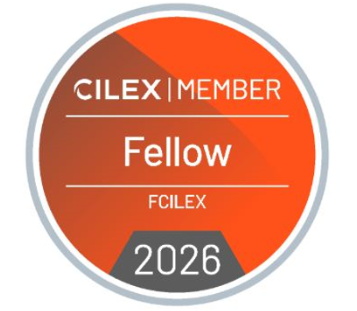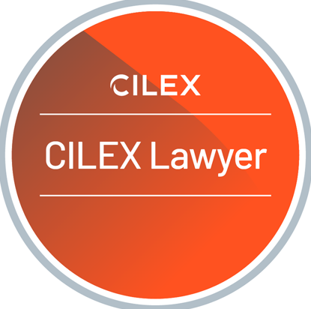
WorkSafe & Legal is not an authorised law firm and does not provide reserved legal services except where acting through an authorised individual or entity in accordance with the Legal Services Act 2007.
2. Clear distinction between “legal services” and “McKenzie Friend services”
When providing McKenzie Friend services, Abraham Blay does not act as a legal representative, does not conduct litigation, and does not exercise rights of audience unless expressly permitted by the court.
3. Complaints escalation clarity
CILEX Regulation regulates individual Chartered Legal Executives. It does not resolve fee disputes but may consider complaints about professional conduct.
4. Client money statement
WorkSafe & Legal does not hold client money and does not operate a client account.
5. Professional Indemnity Insurance (PII) statement
Professional indemnity insurance is maintained appropriate to the nature and scope of services provided.
6. Equality & diversity / reasonable adjustments
WorkSafe & Legal is committed to equality, diversity, and inclusion and will make reasonable adjustments to ensure services are accessible where required.
7. Conflicts of interest policy
We will not act where a conflict of interest arises, or where our independence may reasonably be questioned.
8. Limitation on guarantees of outcome
No guarantee is given as to the outcome of any legal matter.

